During this whole school writing week, the children had a great time reading, writing and performing poetry.
Whole School Performance Poetry Week
24th – 28th March 2025

Monday began with an assembly listening to children and poets performing poetry, and then Class RS burst onto the screen performing Michael Rosen’s hilarious ‘Chocolate Cake’ poem.

Assembly ended with the whole school joining in a performance of ‘We’re Going on a Bear Hunt’ – a poem we all knew very well!
Each class chose a poem to rehearse and perform in Friday assembly, showing off their new-found poetry performing skills – the children and the adults all said they’d had a fun week and the performances were amazing!
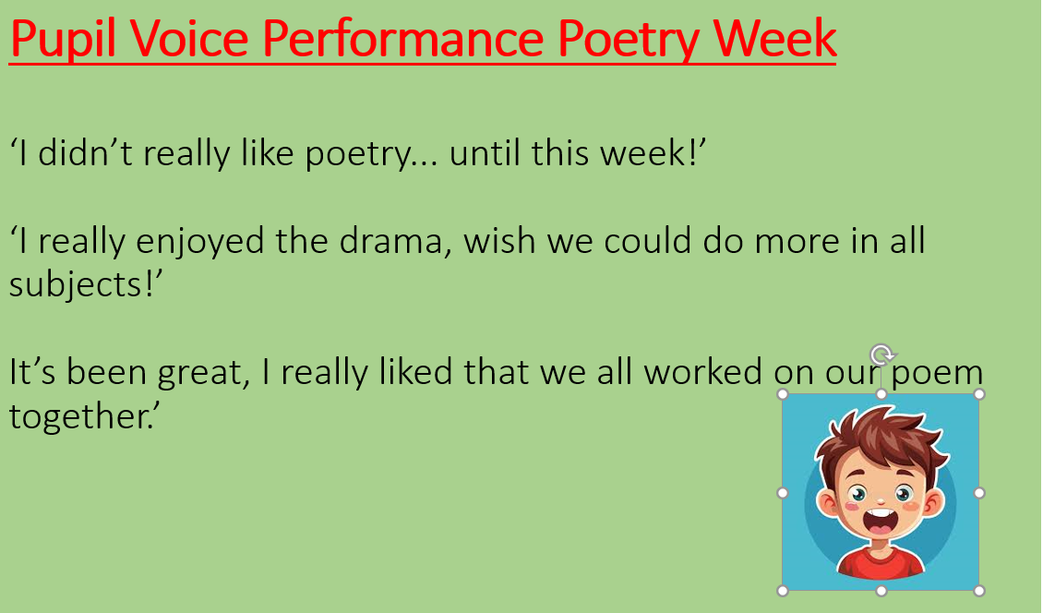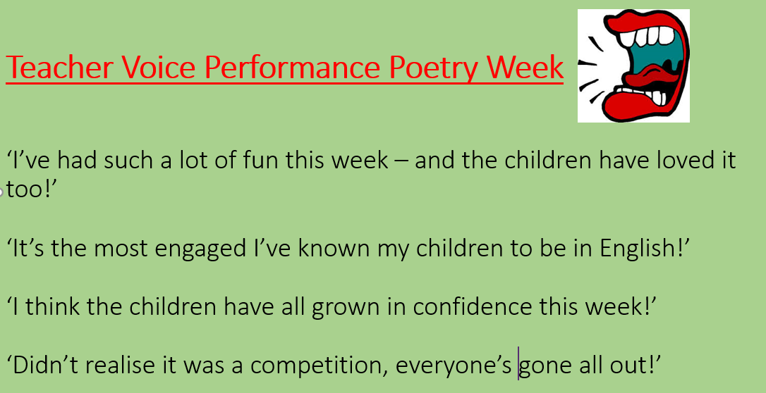
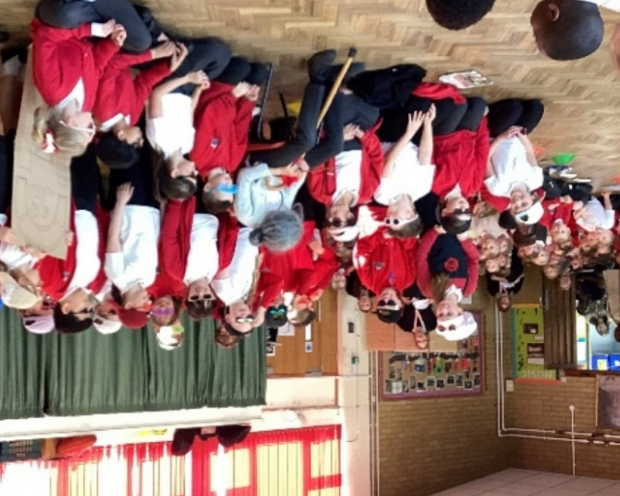
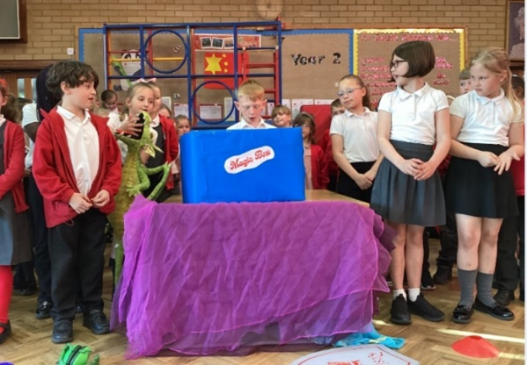

Year 5 performed ‘Gran Can You Rap’ – Jack Ousby Year 3 Performed ‘Magic Box’ – Kit Wright

