Reception have loved their Fairy tale topic and enjoyed dressing up for a Fairy tale Day.
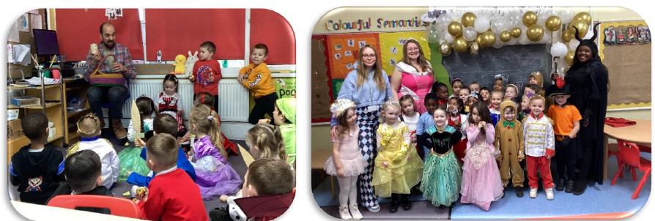
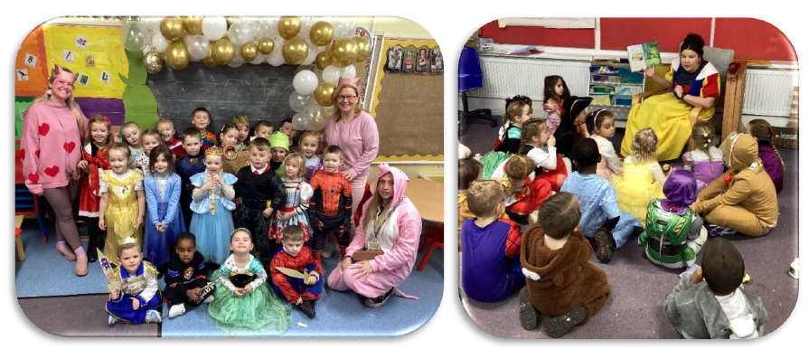
They have been doing a lot of retelling and acting, being very brave and performing in their classes.

