 | Term 1 | Term 2 | Term 3 | Term 4 |  |  | Term 5 | Term 6
EYFS | ADVENTURES  Text - Going on a Bear Hunt  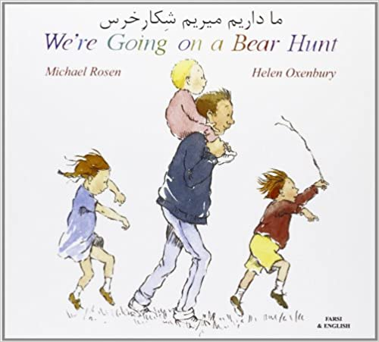 | ADVENTURES → CHRISTMAS  Text - | DINOSAURS  Text – How to Grow a Dinosaur  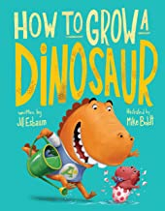 | ONCE UPON A TIME  Text – Three Little Pigs  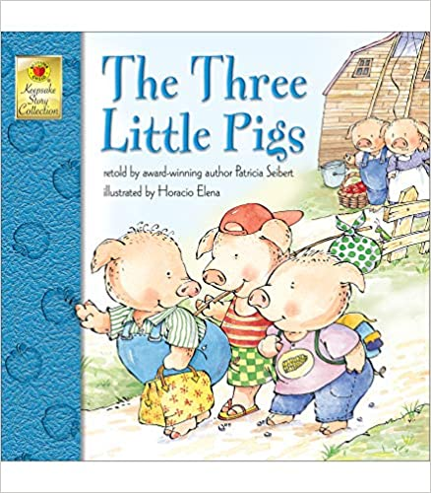 |  |  | PETS  Text - | ON THE FARM  Text -
 | Outcomes  Stories with Familiar Settings  Emergent/Brave Writing | Outcomes  Letters to Santa  Lists | Outcomes  Retelling stories  Stories with fantasy settings | Outcomes  Traditional and Fairy tales |  |  | Outcomes  Non-fiction texts – Fact writing  Lists labels | Outcomes  Stories with fantasy settings
 | Audience | Audience | Audience | Audience |  |  | Audience | Audience
Year 1 | WHERE DO I LIVE?  Text -  Drawing Club  Colour Monster  Gingerbread Man  Pink Panther  Meg and Mog  Goldilocks  Poddington Peas  Don’t Let the Pigeon | LET’S CELEBRATE  Text -  Drawing Club  I’m Coming to Get you  The Elves and the Shoemaker  Trumpton  Snow Queen  Brum  Mog’s Calamity | Exploeres  Text -  Drawing Club-Jimbo  Special Expedition  Clues  Ice story  Diary | TOY STORY  Text -  Where’s my Teddy  Toy Story- World \book Day  Little Red Hen  Jack and the Beanstalk  Performance poetry-Each Peach Pear Plum |  |  | READY, STEADY, GROW!  Text -  Billy Goats Gruff  Cinderella  Plant Instructions  Rabbit Shape Poem | Here Comes the Sun  Text -  Tiddler  Once upon a mermaid’s tale  Lucy and Tom at the Seaside  Winnie at the Seaside
 | Outcomes  Setting descriptions (Local area/house/home setting)  Stories from familiar settings  Character descriptions  Information booklets – maps and local area info | Outcomes  Information texts (non-fiction sentences about festivals)  Poetry on a theme (acrostic poems)  Stories from different cultures  Posters | Outcomes  Information texts (non-fiction sentences about animals)  Diary and recounts  Setting and character descriptions  (animals)  Postcards and letters | Outcomes  Stories from fantasy settings – Pinocchio  Character/setting descriptions (toys)  Information booklets – history of toys  Drama and role play - playscript |  |  | Outcomes  Diary  Recount  Information Booklets (plants/humans)  Poster/Leaflet – guide to growing | Outcomes  Stories from fantasy settings  Traditional tales  Drama and role play – play script  Poetry – ambitions for next year
 | Audience | Audience | Audience | Audience |  |  | Audience | Audience
Year 2 | INSPIRATIONAL PEOPLE  - Vlad and the Florence Nightingale Adventure  - Hoorah for Mary Seacole | GUY FAWKES | CHINA  - The magic crayon  - How to catch a dragon | THE GREAT FIRE OF LONDON  - The Gingerbread man  - Vlad and the Great of London |  |  | MARVELLOUS MONARCHS  - Paddington and the Palace  - The King who banned the dar | AMAZING AUSTRALIA  *NEW TOPIC FOR NEXT YEAR- BOOKS TBC
 | Outcomes  Character description  Narrative  Letter  Biography | Outcomes  Repetitive poems  Story writing  Instructions | Outcomes  Stories from different cultures  Newspaper report | Outcomes  Story writing  Letter writing  Non-chronological report |  |  | Outcomes  Letter writing  Narrative  Recount | Outcomes
 | Audience | Audience | Audience | Audience |  |  | Audience | Audience
Year 3 | Misty Mountains and Winding Rivers | Where do I live?  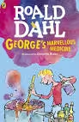  Text - | Dinosaurs  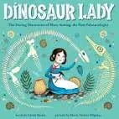 |  | THE STONE AGE  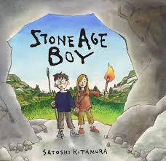 |  | ANCIENT EGYPTIANS  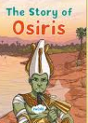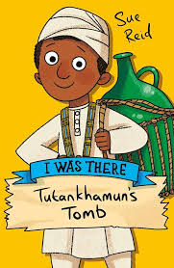 | AMAZING AFRICA  Text -  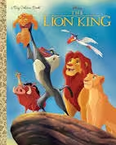
 | Outcomes  Sentence Structure  Autobiography  Poetry  Comparison  Setting Description | Outcomes  Newspaper report  Instructional Text  Poetry | Outcomes  Goal Setting  Recount  Formal Letter  Riddle Poetry  Newspaper Report |  | Outcome  Diary Entry  Mixed up Fairy Tale  Narrative (Quest)  Performance Poetry  Persuasive leaflet |  | Outcomes  Non-Chronological Report  Narrative (Myth)  Diary Entry  Instructional Text | Outcomes  Poetry  Narrative  Playscript
 | Audience  For children and friends with a purpose to entertain and inform  To build confidence with sentence composition | Audience  Inform, describe and explain- Friends, children and teacher. | Audience  Describe, entertain and inform -  Children, friends and parents  Argue and persuade - Geological society |  | Audience  Describe, entertain -  Children, friends and parents  Inform, instruct and advise -  Friends and children |  | Audience  Describe, entertain -  Children, friends and parents  Inform, instruct and advise -  Friends and children | Audience  Describe, entertain -  Children, friends and parents  Inform, instruct and advise -  Friends and children
Year 4 | ROMANS  (ROMANS AND GLADIATORS)  Text - |  | AROUND THE WORLD IN 80 DAYS  (RAINFOREST AND UNDER THE SEA)  Text - |  |  |  | RAIDERS AND INVADERS  (ANGLO-SAXONS AND VIKINGS)  Text -
 | Outcomes  T1 - Fiction myths – rags to riches  Non-fiction – Non-chron reports  T2 Story writing  Chronological reports, recount, diary, newspaper recount |  | Outcomes  Poetry - Survivor story  Non-fiction – informal letter, information text, newspaper report, instruction text  Fiction- Stories- narrative  Non-fiction- Explanation texts, film review, diary entry, recount of trip, discussion text/debate, explanation text |  |  |  | Outcomes  Fiction – historical and myth based  Poetry  Historical and fantasy narrative  Persuasive writing
 |  |  | Audience |  |  |  | Audience
Year 5 | SPACE  Text - | ANTARTICA  Text -  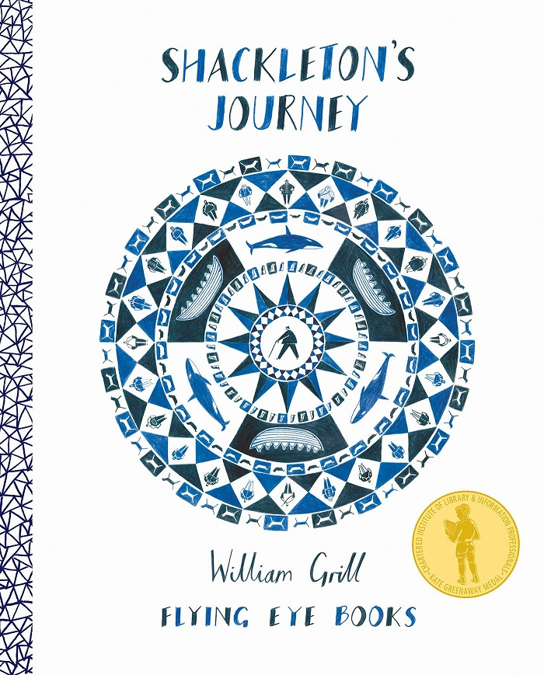 | ANCIENT GREEKS  Text - | LONDON  Text - |  |  |  | MAYANS  Text -
 | Outcomes  Recount  Explanation texts  Newspaper report  Curiosity (RWP) | Outcomes  Non-Chron report  Diary and letter (Biographies)  Job description | Outcomes  Traditional Tales/Myths  Story  Atmospheric writing  (Character and setting)  Who let the God’s out (RWP) | Outcomes  Narrative – Modern London  T4- Boy in the Tower (RWP)/Shakespeare (Playscript)  T5- The Highwayman (highway road to London – A2)  Narrative poem  T5- Hans Christian Anderson – Journey tale/rags to riches |  |  |  | Outcomes  Narrative – Folktale  Non-Chron Report  Information text
 | Audience | Audience | Audience | Audience |  |  |  | Audience
Year 6 | SURVIVORS – NATURAL DISASTERS  Text -  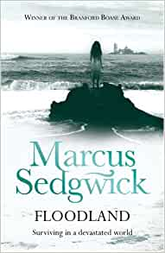 |  | WORLD WAR TWO  Text -  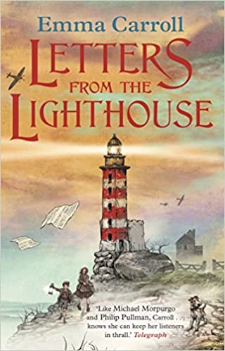 |  |  | INSPIRE ME- FINDING OUR HIDDEN IDENTITIES  Text -
 | Outcomes  T1 Adventure Narrative/Scene setting/Diary/News report/discussion or Comparison  T2 Poetry/ Character description/Dystopian ending/Non-chron report/Persuasive argument |  | Outcomes  T3 Diary/short story/playscript/Propaganda/biography/letter  T4 Evacuee letter/evacuee narrative/book trailer/news report |  |  | Outcomes  T5 First person narrative  Non-chron narrative
 | Audience |  | Audience |  |  | Audience

