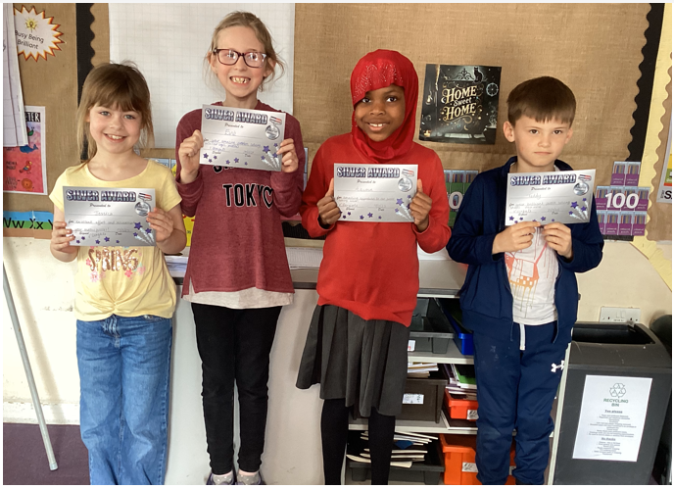

We held a Maths Puzzle week across the school in Term 4! Children were presented with a selection of puzzles which required them to work on a range of problem-solving skills. They were encouraged to work systematically, pick out the most important clues first and try to come up with their own recording systems. Finally, and most importantly, they had to self-check to see if their final answers were correct. A celebration assembly was held on Friday where certificates were handed out.